

**AP Calculus BC**

Q2 Interim Assessment

Test Booklet 1

Multiple Choice - Non-Calc

January 2017

School: _____________________________________________

Student Name: _____________________________________________

Teacher: _____________________________________________

Period: _____________________________________________

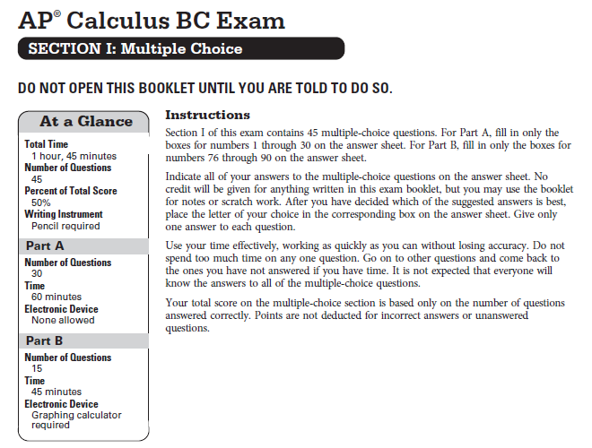

CALCULUS BC

SECTION I, Part A

Time – 60 minutes

Number of questions – 30

NO CALCULATOR IS ALLOWED FOR THIS PART OF THE EXAM.

Directions: Solve each of the following problems, using the available space for scratch work. After examining the form for the choices, decide which of the choices given and place the letter of your choice in the corresponding box on the answer sheet. No credit will be given for anything written in this exam booklet. Do not spend too much time on any one problem.

In this exam:

1. Unless otherwise specified, the domain of a function $f$ is assumed to be the set of all real numbers $x$ for which $f\left(x\right)$ is a real number.
2. The inverse of a trigonometric function $f$ may be indicated using the inverse function notation $f^{-1}$ or with the prefix “arc” (e.g., $\sin^{-1}{x}=\arcsin{x}$).
3. If $f\left(x\right)=\frac{1}{\sqrt{x}}$, then $f^{''}\left(4\right)=$






$-4$

$-\frac{1}{16}$

$\frac{3}{128}$

$24$

$\lim_{x→0}{\frac{6x^{3}+12x^{2}}{-10x^{3}+5x^{2}}=}$

$-\frac{3}{5}$

$0$

$\frac{12}{5}$

11. The limit does not exist.

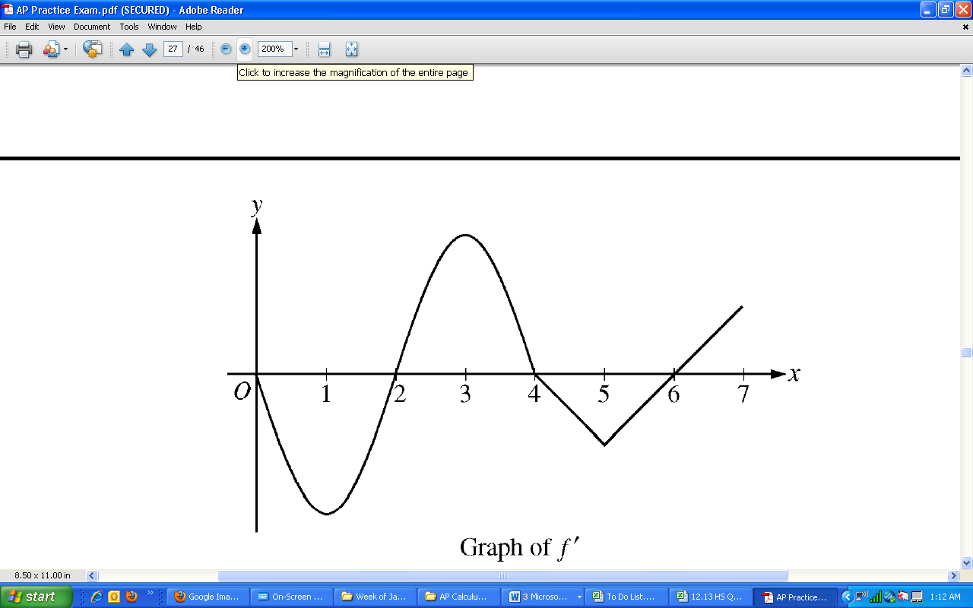

1. The graph of $f'(x)$, the derivative of the function $f$, is shown above. On which of the following intervals is $f$ both concave up and decreasing?

1. $[0, 1]$ only
2. $[1, 2]$ only
3. $[2,3]$ only
4. $[1, 2]$ and $[5, 6]$



$If \int_{10}^{14}{f\left(x\right)}dx=-4, then \int_{14}^{10}{(3f(x)}-10)dx=$

$-28$

$-22$

$22$

$52$

9. If $\frac{dy}{dt}= -10e^{-t/2}$ and $y\left(0\right)=20$, what is the value of $y(6)$?
10. $20e^{-6}$ (B) $20e^{-3}$ (C) $10e^{-3}$ (D) $5e^{-3}$
11. If $y=\tan\left(10x\right)$, $\frac{dy}{dx}=$



$-10\sec^{2}\left(10x\right)$

$10\sec^{2}\left(10x\right)$

$-10\csc^{2}{(10x)}$

$10\tan\left(10x\right)\sec{(10x)}$

16. The function $f$ is continuous on the closed interval $[6, 8]$ and twice differentiable on the open interval $(6, 8)$. If $f^{'}\left(x\right)<0$ and $f^{''}\left(x\right)>0$ for all $x$ on the open interval $(6, 8)$, which of the following could be a table of values for $f$?

|  |  |  |  |  |  |  |  |  |  |  |
| --- | --- | --- | --- | --- | --- | --- | --- | --- | --- | --- |
| (A) | |  | (B) | |  | (C) | |  | (D) | |
| x | $$f(x)$$ |  | $$x$$ | $$f(x)$$ |  | $$x$$ | $$f(x)$$ |  | $$x$$ | $$f(x)$$ |
| 6 | 12 |  | 6 | 15 |  | 6 | 4 |  | 6 | 7 |
| 7 | 10 |  | 7 | 9.5 |  | 7 | 7 |  | 7 | 4 |
| 8 | 8 |  | 8 | 6.5 |  | 8 | 14 |  | 8 | 0 |

1. For values of $h$ very close to $0$, which of the following functions best approximates

$f\left(x\right)=\frac{\csc{(x+h)}-\csc{x}}{h}$?

$-\csc{x}\cot{x}$

$-\csc^{2}{x}$

$\csc{x}\cot{x}$

$\frac{\csc{x}}{x}$

5. The area of the region enclosed between the curves $f\left(x\right)=9-x^{2}$ and $g\left(x\right)=-3+2x^{2}$ is exactly:
$8$

$16$

$32$

$64$

6. If the substitution $x=2+5t$ is used, which of the following is equivalent to

$\int_{0}^{2}{\sin\left(2+5t\right)}dt$?

$\int_{0}^{2}{\sin{x}}dx$

$\frac{1}{5}\int_{2}^{12}{\sin{x}}dx$

$\int_{2}^{12}{\sin{x}}dx$

$5\int_{2}^{12}{\sin{x}}dx$

1. Let $f$ be the function given by $f\left(x\right)=2x^{3}-5$. What is the value of $c$ that satisfies the conclusion of the Mean Value Theorem of differential calculus on the closed interval $\left[0, 2\right]$?

$\frac{\sqrt{2}}{2}$

$\frac{2\sqrt{3}}{3}$

$\frac{4}{3}$

$8$

|  |  |  |  |  |
| --- | --- | --- | --- | --- |
| $x$ ­ | $$0$$ | $$1$$ | $$2$$ | $$3$$ |
| $$f'(x)$$ | $$2$$ | $$0$$ | $$-3$$ | $$8$$ |

1. The polynomial function $f$ has selected values of its first derivative $f'$ given in the table above. Which of the following statements must be true?
2. $f$ is decreasing on the interval $(0, 2)$.
3. $f$ has a local maximum at $x=1$.
4. $f$ has a local minimum on the interval $(2, 3)$.
5. $f$ has an inflection point on the interval $(0, 2)$.
6. The function $f\left(x\right)=80x^{3}+15x^{4}-6x^{5}$ has a relative minimum at $x=$

$-2$

$0$

$2$

$4$

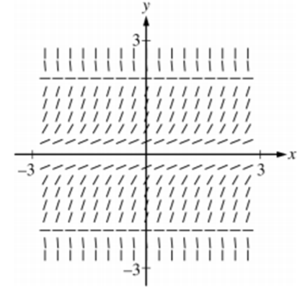

1. Shown above is a slope field for the differential equation $\frac{dy}{dx}=y^{2}\left(4-y^{2}\right)$. If $y=g(x)$ is the solution to the differential equation with the initial condition $g\left(-2\right)=-1$, then $\lim_{x→∞}{g(x)}$ is
2. $-∞$ (B) $-2$ (C) $0$ (D) $3$
3. The region enclosed by the graph of $y=x^{2}$, the line $y=4$, and the line $x=0$ in the first quadrant is rotated about the $x$-axis. Which of the following integrals represents the volume of the resulting solid?

(A) $π\int_{0}^{2}{\left(4-x^{2}\right)dx}$

(B) $π\int_{0}^{4}{\left(16-x^{4}\right)dx}$

(C) $π\int_{0}^{2}{\left(16-x^{4}\right)dx}$

(D) $π\int_{0}^{2}{x^{4}dx}$

1. The function $f$ is defined by $f\left(x\right)=\frac{x}{x-1}$. What points $\left(x, y\right)$ on the graph of $f$ have the property that the line tangent to $f$ at $\left(x, y\right)$ has slope $-1$?
2. $\left(0, 0\right)$ only
3. $\left(-1,\frac{1}{2}\right)$ only
4. $(2, 2)$ only
5. $(0, 0)$ and $\left(2, 2\right)$

$\int{x}\cos{x}dx=$

$x\sin{x}-\cos{x}+C$

$x\sin{x}+\cos{x}+C$

$x\sin{x}+C$

$\frac{1}{2}x^{2}\sin{x}+C$

|  |  |  |
| --- | --- | --- |
| $$x$$ | $$f\left(x\right)$$ | $$f'(x)$$ |
| $$0$$ | $$2$$ | $$7$$ |
| $$4$$ | $$-10$$ | $$3$$ |
| $$7$$ | $$4$$ | $$-10$$ |

1. The table above gives selected values for a differentiable and increasing function $f$ and its derivative. If $g$ is the inverse function of $f$, what is the value of $g'(4)$?



$-10$

$-\frac{1}{10}$

$\frac{1}{4}$

$\frac{1}{3}$

6. For time $t≥0$, the position of a particle traveling along a line is given by a differentiable function $s$. If $s$ is increasing for $0≤t<2$ and $s$ is decreasing for $t>2$, which of the following is the total distance the particle travels for $0≤t≤5$?







$s\left(0\right)+\int_{0}^{2}{s'(t)}dt-\int_{2}^{5}{s'(t)}dt$

$\int_{2}^{5}{s'(t)}dt-\int_{0}^{2}{s'(t)}dt$

$\left|\int_{0}^{5}{s'(t)}dt\right|$

$\int_{0}^{5}{\left|s'(t)\right|}dt$

$\int{\frac{9}{x^{2}-7x+10}dx=}$

$27\ln\left|\frac{x-5}{x-2}\right|+C$

$\frac{1}{2}\ln\left|x^{2}-7x+10\right|+C$

$3\ln\left|\frac{x-5}{x-2}\right|+C$

$3\ln\left|\frac{x-2}{x-5}\right|+C$

15. The function $f$ has the property that $f\left(x\right)<0$, $f^{'}\left(x\right)>0$, and $f^{''}\left(x\right)<0$ are for all real values $x$. Which of the following could be the graph of $f$?

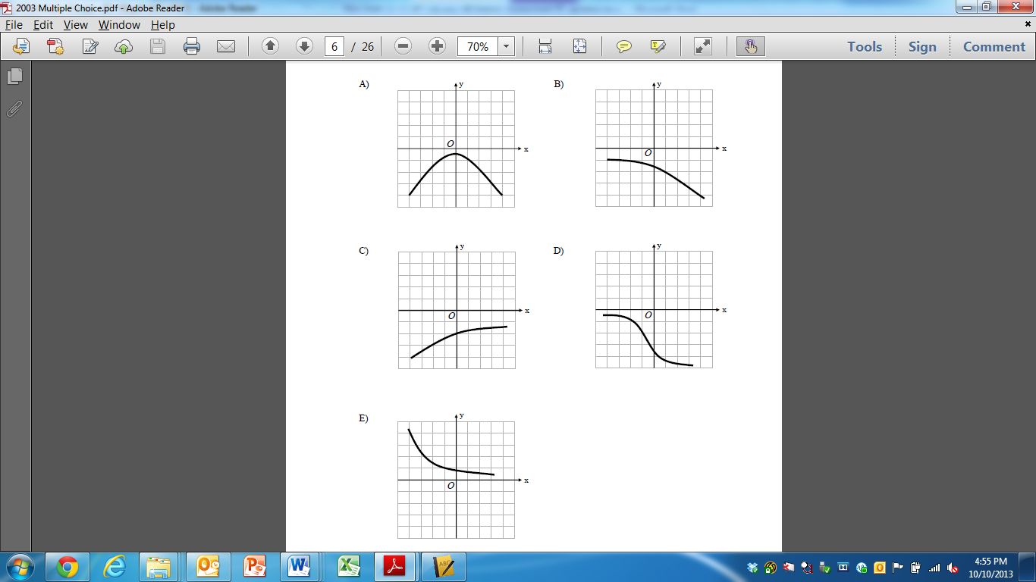

1. Let $S$ be the region enclosed by the curve $y=\frac{1}{\sqrt{x}}$ and the lines $x=1$ and $x=3$. Find the volume of the solid whose base is the region $S$ and whose cross sections perpendicular to the $x$-axis are semi-circles.



$\frac{π}{12} {units}^{2}$

$\frac{π}{6} {units}^{2}$

$\frac{π ln⁡(3)}{4} {units}^{2}$

$\frac{π\ln\left(3\right)}{8} {units}^{2}$

6. If $y=6-2x$, what is the maximum value of the product $3xy$?



$\frac{3}{2}$

$3$

$\frac{9}{2}$

$\frac{27}{2}$

$\int_{0}^{1}{xe^{4x^{2}}}dx=$

$e^{4}$

$\frac{1}{8}e^{4}$

$8(e^{4}-1)$

$\frac{1}{8}(e^{4}-1)$

11. The region enclosed by the graph of $y=\sqrt{x-4}$ and the lines $y=0$ and $x=10$ is

rotated about the $x$-axis. Which of the following gives the volume of the generated solid?

$$\left(A\right) \int_{4}^{10}{\sqrt{x-4}}dx$$

$$\left(B\right) π\int_{0}^{10}{\left(x-4\right)}dx$$

$$\left(C\right) π\int_{4}^{10}{\sqrt{x-4}}dx$$

$$\left(D\right) π\int_{4}^{10}{\left(x-4\right)}dx$$

1. The radius of a sphere is decreasing at a rate of $4$ centimeters per second. At the instant when the radius of the sphere is $3$ centimeters, what is the rate of change, in square centimeters per second, of the surface area of the sphere?

(A) $-144π$

(B) $-96π$

(C) $-32π$

(D) $-24π$

$\int_{0}^{1}{\frac{e^{x}-1}{e^{x}}dx=}$

$-e$

$-\frac{1}{e}$

$\frac{1}{e}$

$e$

5. Which of the following expressions represents the length of the curve $y=e^{-x^{2}}$ for $x$ from $x=0$ to $x=2$?







$\int_{0}^{2}{\sqrt{1+e^{-2x^{2}}}}dx$

$\int_{0}^{2}{\sqrt{1+4x^{2}e^{-2x^{2}}}}dx$

$\int_{0}^{2}{\sqrt{1-e^{-2x^{2}}}}dx$

$\int_{0}^{2}{\sqrt{1+2xe^{-2x^{2}}} dx}$

$\int_{1}^{2}{\frac{x+1}{x^{2}+2x}}dx=$

$\ln{8}-\ln{3}$

$\frac{\ln{8}-\ln{3}}{2}$

$\frac{3\ln{2}}{2}$

$\frac{3\ln{2}+2}{2}$

14. For $0<x<\frac{π}{2}$, if $y={\left(\cos{x}\right)}^{4x}$, then $\frac{dy}{dx}$ is

$-({\cos{x})}^{4x}\tan{x}$

$-4x{\left(\cos{x}\right)}^{4x-1}\sin{x}$

${\left(\cos{x}\right)}^{4x}\left(4\ln\left(\cos{x}\right)+4x\tan{x}\right)$

${\left(\cos{x}\right)}^{4x}\left(4\ln\left(\cos{x}\right)-4x\tan{x}\right)$

**END OF PART A**

**IF YOU FINISH BEFORE TIME IS CALLED,**

**YOU MAY CHECK YOUR WORK ON PART A ONLY.**

**DO NOT GO ON TO PART B UNTIL YOU ARE TOLD TO DO SO**